Berthoud Snowfest
SPONSORSHIP INFORMATION
CLICK HERE to find out sponsorship opportunities for this state-wide event. Berthoud Snowfest is the home of the "Colorado Snow Sculpting Championship"
Deadline to be on the Poster is October 29
VENDOR INFORMATION
This year we will be having the Artisan Market
in downtown Berthoud inside
New Freedom Outreach Center
250 Mountain
December, 14, 2019.
CLICK HERE to download the vendor form.
CLICK HERE to register online for the Artisan Market.
You need to have a Berthoud Sales Tax Licence number to be a vendor. Click Here to download that form. You need to have a State of Colorado Tax License to get your Berthoud one. If you only need a State of Colorado Special Events Tax License CLICK HERE.

CLICK HERE to sign up to volunteer to Snowfest...lots of fun opportunities.

Kids' Snow Sculpting Event &
Reindeer Photo Shoot
CLICK HERE to register for the Kid Sculpting Event
at Fickel Park - Thursday, December 12, 2019 at 3:00 pm.
During the Kid's Snow Sculpting Event from 3:00 - 5:00 pm, we'll have reindeer at the park. Come get your picture taken with the reindeer. Two lucky families will get the opportunity to get inside the reindeer pen and get their pictures taken. But, you must get signed up for the kids' snow sculpting event for a chance to win. There will be one winner between 3 - 4 pm and one winner between 4 - 5 pm. The reindeer will be coming from the Jessen Reindeer Ranch and sponsored by NoCo Hemp Expo.
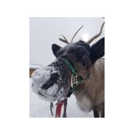
Come See Me
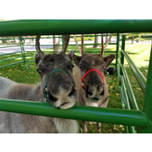
Come Take Our Picture
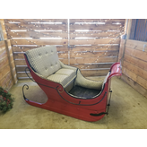
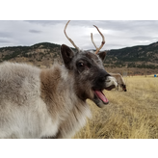
I am a real reindeer!
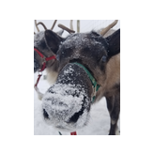
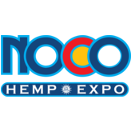

Lighted Parade
CLICK HERE to register for the Lighted Parade
that travels down Mountain Avenue
Saturday, December 14, 2019 at 5:00 pm.
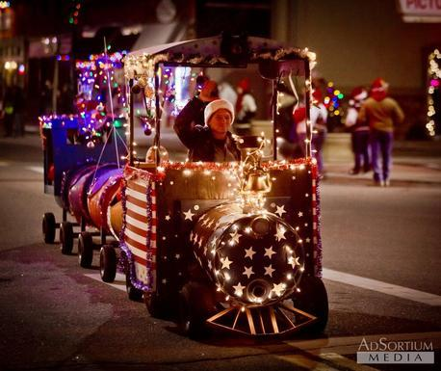

Other Community Events
Wildfire Local Artist Market - Holiday Show
Reception - Friday, December 6 -- 6:00 - 9:00 pm
Sale - Saturday, December 7 -- 10:00 am - 4:00 pm
425 Massachusetts Avenue, Berthoud
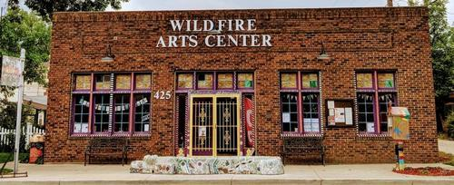

The Kilted Man - Berthoud Community Library District
Thursday, December 12 -- 10:30 am
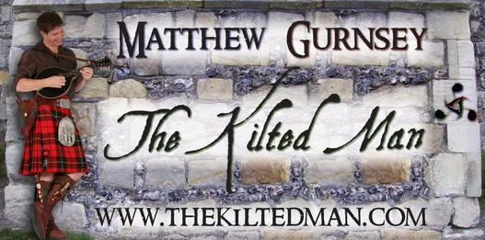

Larimer County Horseman's Association Caroling
Saturday, December 14 -- 11:30 am - 1:30 pm
Starting at 7th and Massachusetts and caroling through the neighborhoods of Berthoud on horseback with Hay Rides.
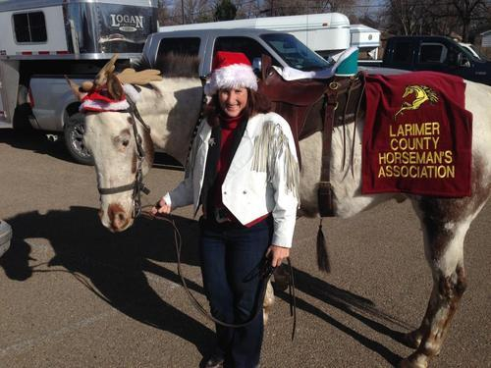

Recap of Berthoud SNOWFEST 2018!

December 12 - 15, 2018

Berthoud SNOWFEST is a winter festival as well as the sanctioned Colorado Snow Sculpting Championship held in Berthoud, Colorado on 7th Street (west side of Fickel Park).
2018 Snow sculptures were on view on 7th Street between Mountain Avenue and Massachusetts Avenue during the Snowfest event.
CONGRATULATIONS TO ALL OF OUR SNOW SCULPTING TEAMS!
Here are the results of the judging:
all the pictures you need are in Ben’s Drop Box

